Appendix 7A: Difficulties Solving for An Interest Rate

7A-1
Year | Cash Flow
0 | +$4,000
1-9 | +$4,000
10 | -$71,000
11-19 | +$4,000

There are 2 sign changes in the cash flow indicating there may be 2, 1, or zero positive interest rates.

At i = 0% NPW= +$5,000
At i = ∞% NPW =+$4,000

This suggests that the NPW plot may look like one of the following:

NPW
0
i ∞
Figure A
$5,000
NPW
0
i ∞
Figure B
$5,000
After making a number of calculations, one is forced to conclude that Figure B is the general form of the NPW plot, and there is no positive interest rate for the cash flow.

There is external investment until the end of the tenth year. If an external interest rate (we will call it e* in Chapter 18) is selected, we can proceed to solve for the interest rate i for the investment phase of the problem.

For external interest rate = 6%
Future worth of $4,000 a year for 10 years (11 payments)
= $4,000 (F/A, 6%, 11) = $4,000 (14.972) = $59,888
At year 10 we have +$59,888 -$75,000 = -$15,112

The altered cash flow becomes:
Year | Cash Flow
0 | 0
1-9 | 0
10 | -$15,112
11-19 | +$4,000

At the beginning of year 10:
PW of Cost = PW of Benefits
$15,112 = $4,000 (P/A, i%, 9)

(P/A, i%, 9) = $15,112/$4,000 = 3.78

By linear interpolation from interest tables, i = 22.1%.

The internal interest rate is sensitive to the selected external interest rate:
For external  Interest rate | Computed internal  Interest rate
0% | 3.1%
6% | 22.1%
8% | 45.9%

7A-2
The problem statement may be translated into a cash flow table:

Year | Cash Flow
0 | +$80,000
1 | -$85,000
2 | -$70,000
3 | 0
4 | +$80,000
There are two sign changes in the cash flow indicating there may be as many as two positive rates of return.

To search for positive rates of return compute the NPW for the cash flow at several interest rates. This is done on the next page by using single payment present worth factors to compute the PW for each item in the cash flow. Then, their algebraic sum represents NPW at the stated interest rate.

Year | Cash Flow | PW at 0% | PW at 8% | PW at 9% | PW at 25% | PW at 30%
0 | +$80,000 | +$80,000 | +$80,000 | +$80,000 | +$80,000 | +$80,000
1 | -$85,000 | -$85,000 | -$78,700 | -$77,980 | -$68,000 | -$65,380
2 | -$70,000 | -$70,000 | -$60,010 | -$58,920 | -$44,800 | -$41,420
3 | 0 | 0 | 0 | 0 | 0 | 0
4 | +$80,000 | +$80,000 | +$58,800 | +$56,670 | +$32,770 | +$28,010
 |  | +$5,000 | +$90 | -$230 | -$30 | +$1,210

+$5,000
-$2,000
0% 10% 20% 30%i
The plow of NPW vs. i shows two positive interest rates: i ≈ 8.2% and i ≈ 25%

Using an external interest rate of 6%, the Year 0 cash flow is invested and accumulates to +$80,000 (1.06) = $84,800 at the end of Year 1. The revised cash flow becomes:

Year | Cash Flow
0 | 0
1 | -$200
2 | -$70,000
3 | 0
4 | +$80,000

With only one sign change we know there no longer is more than one positive interest rate.

PW of Benefit = PW of Cost, or PW(Benefit) – PW(Cost) = 0

$80,000 (P/F, i%, 4) - $200 (P/F, i%, 1) - $70,000 (P/F, i%, 2) = 0

Try i = 7%
80,000 (0.7629) - $200 (0.9346) - $70,000 (0.8734) = -$293

Try i = 6%
$80,000 (0.7921) - $200 (0.9434) - $70,000 (0.8900) = +$879

By interpolation, i = 6.75%.

7A-3
(a)
Quarter | Quarterly Cash Flow | PW at 0% | PW at 20% | PW at 40% | PW at 45%
0 | -$75 | -$75 | -$75.0 | -$75.0 | -$75.0
1 | +$75 | +$75 | +$62.5 | +$53.6 | +$51.7
2 | -$50 | -$50 | -$34.7 | -$25.5 | -$23.8
3 | +$50 | +$50 | +$28.9 | +$18.2 | +$16.4
4 | +$125 | +$125 | +$60.3 | +$32.5 | +$28.3
Sum |  | +$125 | +$42.0 | +$3.8 | -$2.4

By interpolation, i ≈ 43% per quarter. The nominal rate of return = 4 (43%) = 172% per year.

(b)

Quarter | Quarterly Cash Flow | Transformed Cash Flow
0 | -$75 | -$75
1 | +$75 | +$26.46
2 | -$50 | 0
3 | +$50 | +$50
4 | +$125 | +$125

Let X = amount required at end of quarter 1 to produce $50 at the end of 2 quarters:

X (1.03) = $50
X = $50/1.03 = $48.54

Solve the Transformed Cash Flow for the rate of return:

Quarter | Transformed Cash Flow | PW at 35% | PW at 40%
0 | -$75 | -$75.00 | -$75.00
1 | +$26.46 | +$19.60 | +$18.90
2 | 0 | 0 | 0
3 | +$50 | +$20.32 | +$18.22
4 | +$125 | +$37.64 | +$32.54
Sum |  | +$2.56 | -$5.34

Rate of return = 35% + 5% (2.56/(2.56 – (-5.34)))
= 36.6% per quarter
Nominal annual rate of return = 36.6% x 4 = 146%

NOTE: Although there are three sign changes in the cash flow, the accumulated cash flow sign test, (described in Chapter 18) indicates there is only a single positive rate of return for the untransformed cash flow. It is 43%.

(c) In part (a) the required external investment in Quarter 1, for return in Quarter 2, is assumed to be at the internal rate of return (which we found is 43% per quarter).

In part (b) the required external investment is at 3% per quarter.

The “correct” answer is the one for the computation whose assumptions more closely fit the actual problem. Even though there is only one rate of return, there still exists the required external investment in Quarter 1 for Quarter 2. On this basis the Part (b) solution appears to have more realistic assumptions than Part (a).

7A-4
Year | Cash Flow
0 | -$500
1 | +$2,000
2 | -$1,200
3 | -$300
Sum | 0

There are two sign changes in the cash flow indicating as many as two positive rates of return. The required disbursement in Year 2 & 3 indicate that money must be accumulated in an external investment to provide the necessary Year 2 & 3 disbursements.

Before proceeding, we will check for multiple rates of return. This, of course, is not necessary here.

Since the algebraic sum of the cash flow = $0, we know that NPW at 0% = 0, and 0% is a rate of return for the cash flow.

Looking for the other (possible) rate of return:

Year | Cash Flow | PW at 5% | PW at 50% | PW at 200% | PW at 219% | PW at 250% | PW at ∞%
0 | -$500 | -$500 | -$500 | -$500 | -$500 | -$500 | -$500
1 | +$2,000 | +$1,905 | +$1,333 | +$667 | +$627 | +$571 | $0
2 | -$1,200 | -$1,088 | -$533 | -$133 | -$118 | -$98 | $0
3 | -$300 | -$259 | -$89 | -$11 | -$9 | -$7 | $0
 | NPW = | +$58 | +$211 | +$23 | 0 | -$34 | -$500

+$500
-$500
0% 219% i
Solution using an external interest rate e* = 6%.

How much of the +$2,000 at Year 1 must be set aside in an external investment at 6% to provide for the Year 2 and Year 3 disbursements?
Amount to set aside = $1,200 (P/F, 6%, 1) + $300 (P/F, 6%, 2)
= $1,200 (0.94.4) + $300 (0.8900)
= $1,399.08

The altered cash flow becomes:

Year | Cash Flow
0 | -$500
1 | +$2,000 -$1,399.08 = +$600.92
2 | 0
3 | 0

Solve the altered cash flow for the unknown i:

$500 = $600.92 (P/F, i%, 1)
(P/F, i%, 1) = $500/$600.92 = 0.8321

From tables: 20.2%

7A-5
Year | Cash Flow |  | Altered Cash Flow | PW at 18% | PW at 20%
0 | -$500 |  | -$500
1 | +$2,000 | $200(1.06) | 0
2 | -$1,200 | = +$212 | -$288
3 | -$300 |  | +$1,200
 |  |  | +$412 | +$23 | -$6

The rate of return is 18% + (2%) (23/(23 + 6)) = 19.6%

7A-6
Year | Cash Flow | PW at 20% | PW at 35% | PW at 50%
0 | -$100 | -$100 | -$100 | -$100
1 | +$360 | +$300 | +$267 | +$240
2 | -$570 | -$396 | -$313 | -$253
3 | +$360 | +$208 | +$146 | +$107
NPW= | +$50 | +$12 | 0 | -$6

There is a single positive rate of return at 35%.

Year | Cash Flow |  | Altered Cash Flow | PW at 12% | PW at 15%
0 | -$100 |  | -$100 | -$100 | -$100
1 | +$360 | $360(1.06) | 0 | 0 | 0
2 | -$570 | = +$382 | -$188 | -$150 | -$142
3 | +$360 |  | +$360 | +$256 | +$237
 |  |  | +$72 | +$6 | -$5

Rate of return ≈ 13.6%.
For further computations, see the solution to Problem 18-4.

7A-7
Some money flowing out of the cash flow in Year 2 will be required for the Year 3 investment of $100. At 10% external interest, $90.91 at Year 2 becomes the required $100 at Year 3.

Year | Cash Flow |  | Transformed Cash Flow | NPW at 20% | NPW at 25%
0 | -$110 |  | -$110 | -$110.00 | -$110.00
1 | -$500 |  | -$500 | -$416.65 | -$400
2 | +$300 | -$90.91(1.10) | +$209.09 | +$145.19 | +$133.82
3 | -$100 | = +$100 | 0 | 0 | 0
4 | +$400 |  | +$400 | +$192.92 | +$163.84
5 | +$500 |  | +$500 | +$200.95 | +$163.85
 |  |  |  | +$12.41 | -$48.49

The rate of return on the transformed cash flow is 21%. (This is only slightly different from the 21.4% rate of return on the original cash flow because the external investment is small and of short duration.)

7A-8
Year | Cash Flow |  | Transformed Cash Flow | PW at 15%
0 | -$50.0 |  | -$50.0 | -$50.0
1 | +$20.0 |  | 0 | 0
2 | -$40.0 | $20(1.10) | -$18.0 | -$13.6
3 | +$36.8 | = +$22 | +$36.8 | +$24.2
4 | +$36.8 |  | +$36.8 | +$21.0
5 | +$36.8 |  | +$36.8 | +$18.3
 |  |  |  | -$0.1

From the computations we see that the rate of return on the internal investment is 15%.

7A-9
Year | Cash Flow |  | Transformed Cash Flow
0 | -$15,000 |  | -$15,000
1 | +$10,000 |  | +$8,980
2 | +$6,000 | X 1.12 = +$6,720 | 0
3 | -$8,000 |  | 0
4 | +$4,000 | Y (1.12)² = +$1,280 | +$4,000
5 | +$4,000 | Y = $1,020 | +$4,000
6 | +$4,000 |  | +$4,000

Year | Transformed Cash Flow | PW at 10% | PW at 12%
0 | -$15,000 | -$15,000 | -$15,000
1 | +$8,980 | +$8,164 | +$8,018
2 | 0 | 0 | 0
3 | 0 | 0 | 0
4 | +$4,000 | +$2,732 | +$2,542
5 | +$4,000 | +$2,484 | +$2,270
6 | +$4,000 | +$2,258 | +$2,026
Sum |  | +$638 | -$144

Rate of Return = 10% + (2%) (638/(638+144)) = 11.6%

7A-10
The compound interest tables are for positive interest rates and are not useful here. (Tables could be produced, of course, for negative values.)

PW of Cost = PW of Benefits
$50 = $20 (1 + i)⁻¹ + $20 (1 + i)⁻²

let x = (1+ i)⁻¹ thus, $50 = $20x + $20x² or x² + x – 2.50 = 0

x = - 1 + (1² – 4(-2.50))^{1/2} = - 1+ (11)^{1/2} = +1.159, -2.158
2 2

Solving for i:
x = (1 + i)⁻¹ = +1.159 1 + i = 1/1.159 = 0.863 i = -0.137 = -13.7%
x = (1 + i)⁻¹ = -2.158 1 + i = 1/-2.158 = -0.463 i = -1.463 = -146%

7A-11
Year | Cash Flow |  | Transformed Cash Flow
0 | 0 |  | 0
1 | 0 |  | 0
2 | -$20 | X (1.15) = +$10 | -$20
3 | 0 | X = $10/1.15 = $8.7 | 0
4 | -$10 |  | -$10
5 | +$20 |  | +$11.3
6 | -$10 |  | 0
7 | +$100 |  | +$100

Year | Transformed Cash Flow | PW at 35% | PW at 40%
0 | 0 | 0 | 0
1 | 0 | 0 | 0
2 | -$20 | -$11.0 | -$10.2
3 | 0 | 0 | 0
4 | -$10 | -$3.0 | -$2.6
5 | +$11.3 | +$2.5 | +$2.1
6 | 0 | 0 | 0
7 | +$100 | +$12.2 | +$9.5

Rate of return = 35% + 5% (0.7/(0.7+1.2)) = 36.8%

7A-12
Year | Cash Flow |  | Transformed Cash Flow | PW at 25%
0 | -$800 |  | -$800 | -$800
1 | +$500 |  | +$500 | +$400
2 | +$500 | X (1.10) = +$300 | +$227.27 | +$145.5
3 | -$300 | X = $300/1.10 = $272.73 | 0 | 0
4 | +$400 |  | +$400 | +$163.8
5 | +$275 |  | +$275 | +$90.1
 |  |  |  | -0.6

From the Present Worth computation it is clear that the rate of return is very close to 25% (Calculator solution says 24.96%).

7A-13

Year | Cash flow |  | I | PW
0 | -100 |  | 0% | -3 | =$B$2+NPV(D2,$B$3:$B$4)
1 | 240 |  | 10% | 0
2 | -143 |  | 20% | 1
 |  |  | 30% | 0
 |  |  | 40% | -2 |  | 10.00% | root
 |  |  |  |  |  | 30.00% | root
2 sign changes => 2 roots possible
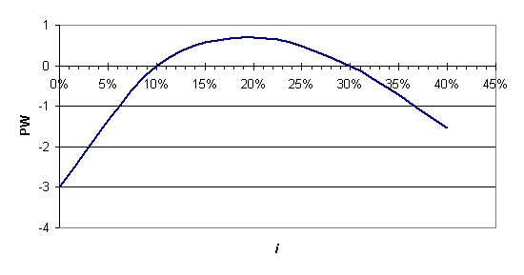
6% | external financing rate
12% | external investing rate
8.8% | MIRR |  | value is less than external investing rate => not attractive

7A-14
Year | Cash flow |  | I | PW
0 | -610 |  | 0% | -110 | =$B$2+NPV(D2,$B$3:$B$12)
1 | 200 |  | 5% | 13
2 | 200 |  | 10% | 41
3 | 200 |  | 15% | 23
4 | 200 |  | 17% | 10 |  | 4.07% | root
5 | 200 |  | 19% | -6 |  | 18.29% | root
6 | 200 |  | 20% | -14
7 | 200 |  | 25% | -57
8 | 200
9 | 200
10 | -1300
2 sign changes => 2 roots possible
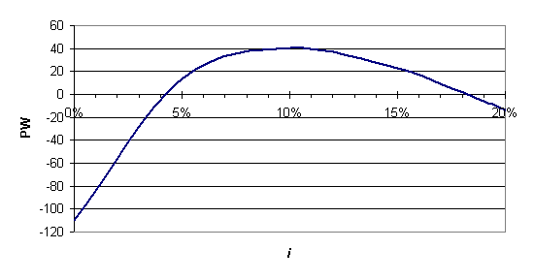

6% | external financing rate
12% | external investing rate
9.5% | MIRR |  | value is less than external investing rate => not attractive

7A-15
Year | Cash flow |  | i | PW
0 | -500 |  | 0% | -80 | =$B$2+NPV(D2,$B$3:$B$5)
1 | 800 |  | 10% | -45
2 | 170 |  | 20% | -34
3 | -550 |  | 30% | -34
 |  |  | 40% | -42 |  | #NUM! | root
 |  |  | 50% | -54 |  | #NUM! | root
 |  |  | 60% | -68 |  | No roots exist
2 sign changes => 2 roots possible
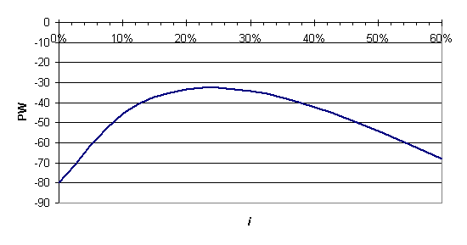

6% | external financing rate
12% | external investing rate
7.5% | MIRR |  | value is less than external investing rate => not attractive

7A-16
Year | Cash flow |  | I | PW
0 | -100 |  | 0% | 0.00 | =$B$2+NPV(D2,$B$3:$B$5)
1 | 360 |  | 10% | -0.23
2 | -428 |  | 20% | 0.00
3 | 168 |  | 30% | 0.14
 |  |  | 40% | 0.00 |  | 0.00% | root
 |  |  | 50% | -0.44 |  | 20.00% | root
 |  |  | 60% | -1.17 |  | 40.00% | root
3 sign changes => 3 roots possible |  |  |  | All PW values = 0 given significant digits of cash flows
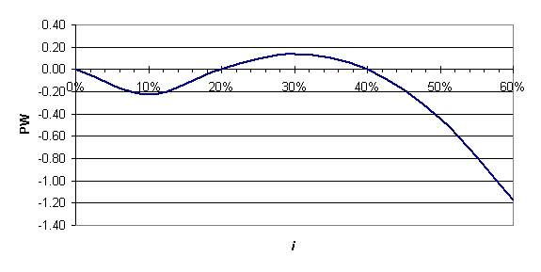

6% | external financing rate
12% | external investing rate
8.8% | MIRR |  | value is less than external investing rate => not attractive

7A-17
Year | Cash flow |  | i | PW
0 | -1200 |  | -45% | -422 | =$B$2+NPV(D2,$B$3:$B$8)
1 | 358 |  | -40% | 970
2 | 358 |  | -30% | 1358
3 | 358 |  | -20% | 970
4 | 358 |  | -10% | 541 |  | 7.22% | root
5 | 358 |  | 0% | 196 |  | -43.96% | root
6 | -394 |  | 10% | -65
 |  |  | 20% | -261
2 sign changes => 2 roots possible
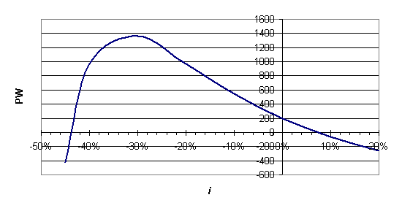

6% | external financing rate
12% | external investing rate
9.5% | MIRR |  | value is less than external investing rate => not attractive

7A-18
Year | Cash flow |  | i | PW
0 | -3570 |  | 0% | 2260 | =$B$2+NPV(D2,$B$3:$B$10)
1 | 1000 |  | 5% | 921
2 | 1000 |  | 10% | -1
3 | 1000 |  | 15% | -651
4 | -3170 |  | 20% | -1120 |  | 10.00% | IRR
5 | 1500 |  |  |  |  | unique IRR
6 | 1500
7 | 1500
8 | 1500
3 sign changes => 3 roots possible
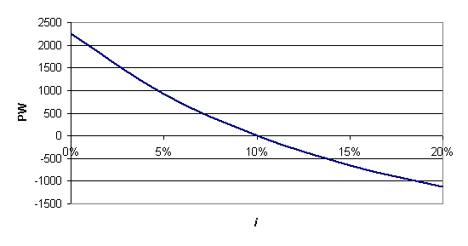

7A-19
800 | down payment
55 | monthly payment |  | 1 sign change => 1 root possible
40 | # payment
2500 | final receipt
-0.75% | IRR monthly | =RATE(A3,-A2,-A1,A4)
-8.62% | effective annual rate
 | =(1+A6)^12-1

7A-20
Year | Cash flow |  | i | PW
0 | -850 |  | 0% | -450 | =$B$2+NPV(D2,$B$3:$B$12)
1 | 600 |  | 5% | -153
2 | 200 |  | 10% | -29
3 | 200 |  | 15% | 7
4 | 200 |  | 17% | 8 |  | 12.99% | root
5 | 200 |  | 19% | 3 |  | 19.72% | root
6 | 200 |  | 20% | -1
7 | 200 |  | 25% | -31
8 | 200
9 | 200
10 | -1800
2 sign changes => 2 roots possible
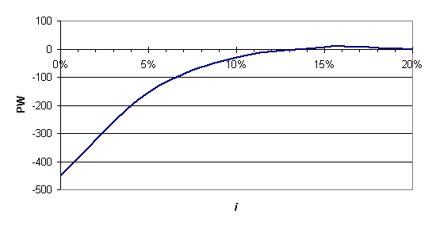

6% | external financing rate
12% | external investing rate
9.1% | MIRR |  | value is less than external investing rate => not attractive

7A-21
Year | Cash flow |  | i | PW
0 | -16000 |  | 0% | 1950 | =$B$2+NPV(D2,$B$3:$B$7)
1 | -8000 |  | 5% | -1158
2 | 11000 |  | 10% | -3639
3 | 13000 |  | 15% | -5644
4 | -7000 |  | 20% | -7284 |  | 3.00% | IRR
5 | 8950 |  |  |  |  | unique IRR
3 sign changes => 3 roots possible
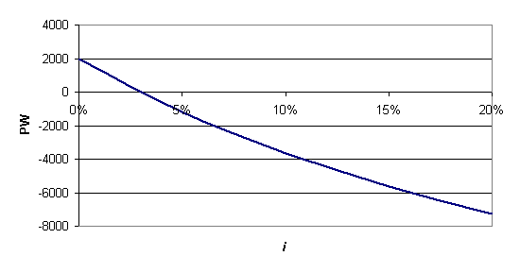

7A-22
Year | Cash flow |  | i | PW
0 | -200 |  | 0% | 176 | =$B$2+NPV(D2,$B$3:$B$10)
1 | 100 |  | 5% | 111
2 | 100 |  | 10% | 63
3 | 100 |  | 15% | 27
4 | -300 |  | 20% | 0 |  | 20.00% | IRR
5 | 100 |  | 25% | -21 |  | unique IRR
6 | 200
7 | 200
8 | -124.5
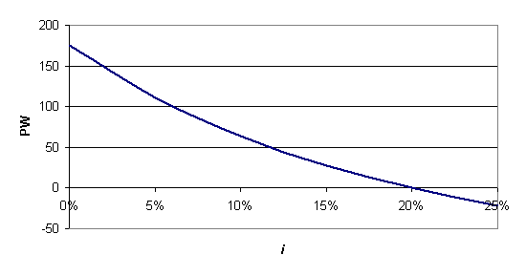
4 sign changes => 4 roots possible

7A-23
Year | Cash flow |  | i | PW
0 | -210000 |  | 0% | 127000 | =$B$2+NPV(D2,$B$3:$B$9)
1 | 88000 |  | 5% | 74284
2 | 68000 |  | 10% | 34635
3 | 62000 |  | 15% | 4110
4 | -31000 |  | 20% | -19899 |  | 15.78% | IRR
5 | 30000 |  |  |  |  | unique IRR
6 | 55000
7 | 65000
3 sign changes => 3 roots possible
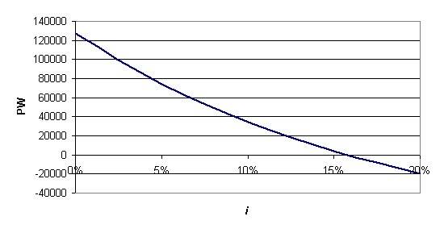

7A-24

Year | Cash flow |  | i | PW
0 | -103000 |  | 0% | 37400 | =$B$2+NPV(D2,$B$3:$B$7)
1 | 102700 |  | 10% | 7699
2 | -87000 |  | 20% | -11676
3 | 94500 |  | 30% | -25003
4 | -8300 |  | 40% | -34594 |  | 13.51% | IRR
5 | 38500 |  |  |  |  | unique IRR
5 sign changes => 3 roots possible
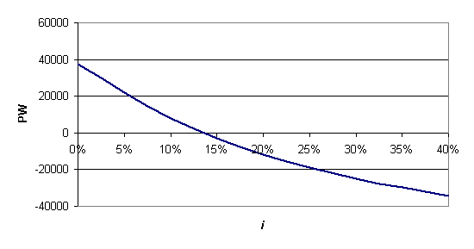

7A-25
Year | Cash flow |  | i | PW
0 | -200 |  | 0% | 100 | =$B$2+NPV(D2,$B$3:$B$4)
1 | 400 |  | 20% | 64
2 | -100 |  | 40% | 35
 |  |  | 60% | 11
 |  |  | 80% | -9 |  | 70.71% | IRR
 |  |  | 100% | -25 |  | unique IRR
2 sign changes => 2 roots possible
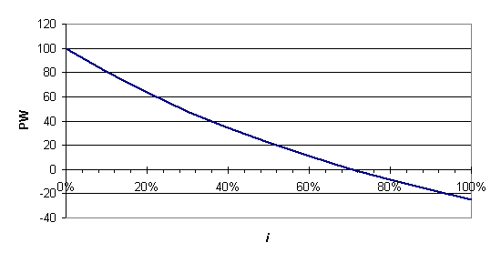

6% | external financing rate
12% | external investing rate
24.5% | MIRR |  | value is more than external investing rate => attractive

7A-26
5 | 6648 | 0 | 6,648 | 50% | 1193 |  | 60.0% | root
6 | 6648 | 0 | 6,648 | 60% | -3
7 | 6648 | 0 | 6,648 | 70% | -1086
8 | 6648 | 0 | 6,648
9 | 6648 | 0 | 6,648
10 | 36648 | 138,000 | -101,352
IRR | 8.0% | 11.0% | 19.2%
2 sign changes => 2 roots possible
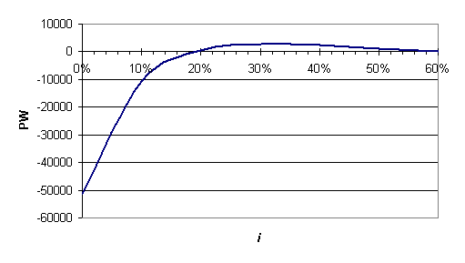
6% | external financing rate
12% | external investing rate
5.1% | MIRR for A-B |  | value is less than external investing rate => not attractive

7A-27
Year | Cash flow |  | i | PW
0 | -1000 |  | 0% | 520 | =$B$2+NPV(D2,$B$3:$B$7)
1 | 60 |  | 5% | 181
2 | 60 |  | 10% | -71
3 | -340 |  | 15% | -261
4 | 0 |  | 20% | -406 |  | 8.44% | IRR
5 | 1740 |  |  |  |  | unique IRR
3 sign changes => 3 roots possible
